Project - newproject (Quiz Application)

About Project -

JDK --JDk 17

IDE --Netbeans IdE 13 [Backend And Frontend ]

Database ---MySQl 8.0 [Backend ]

Swing and AWT [Frontend]

Database Tables –

[Table 1

User - name , password , role ,score

Table 2

Score - score

Table 3

C - id ,question , op1 ,op2 ,op3, op4 ,answer

Table 4

Cpp - id ,question , op1 ,op2 ,op3, op4 ,answer

Table 5

Java - id ,question , op1 ,op2 ,op3, op4 ,answer

Table 6

Html - id ,question , op1 ,op2 ,op3, op4 ,answer

Table 7

OOPS - id ,question , op1 ,op2 ,op3, op4 ,answer

]

Before run this project please paste the MYSQL database query in your database which is

in database.txt file in newproject folder.

This project first page name home page have two category first one for user and second

one is for admin section.

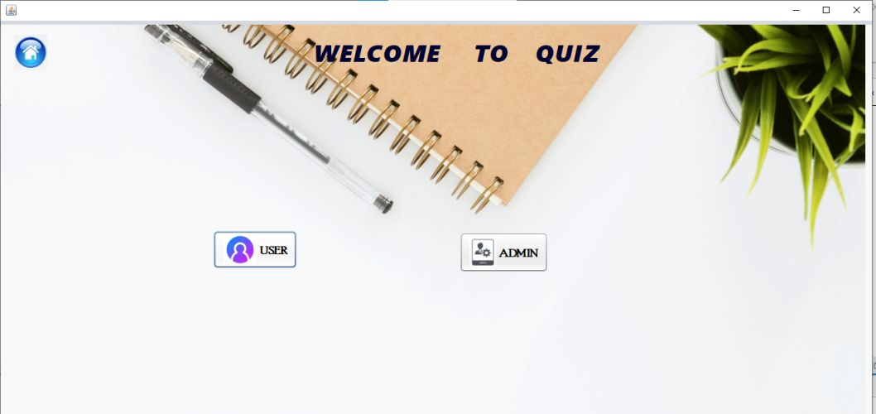

----- USER SECTION --------

USER : In user section first login page open in which we have to enter name, password and

choose the one programming language for quiz question.

In language you can choose C ,Cpp ,Java ,HTML ,OOPS for quiz question. And each section

having 5 quiz questioons .

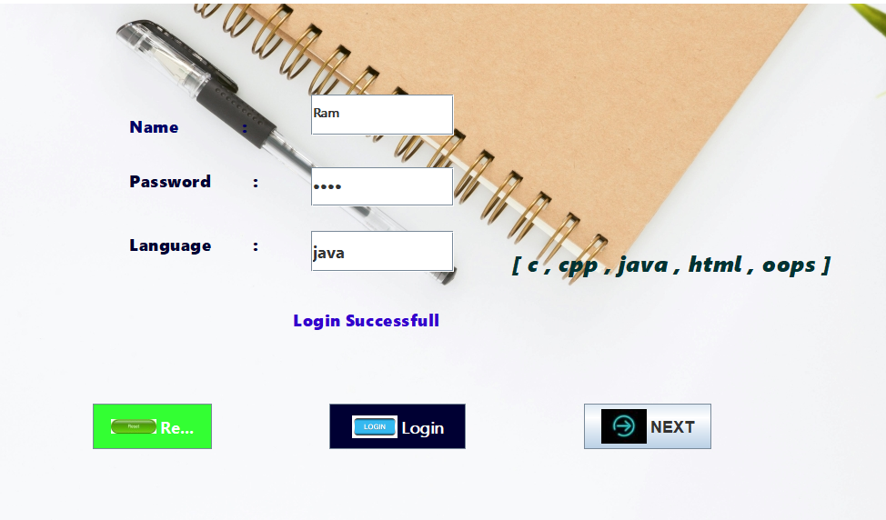

At the Quiz page ----

If you choose any option of given question you have to click on check button to submit

your answer and see the correct answer of the question

and after submission then click on next button for next question . After completing all 5

question submit quiz button will Enabled .

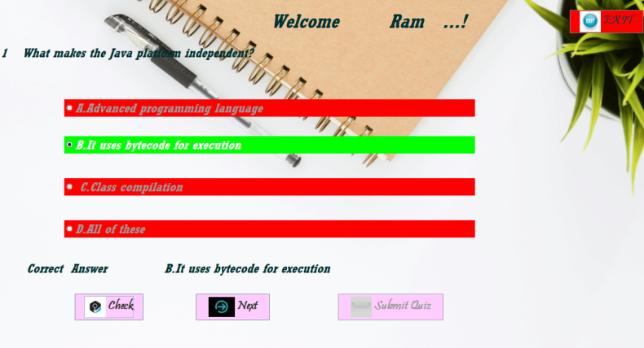

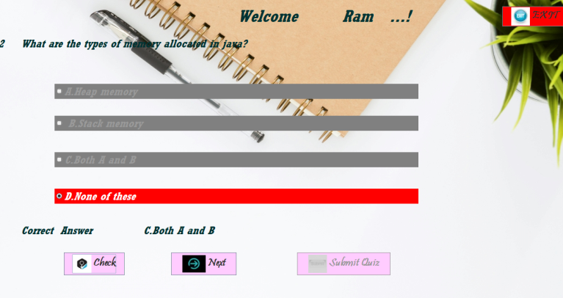

Click on submit quiz button .After the submission of Quiz the score page will open

It will show your entered name , language , your score and its also show the highest score

of user .

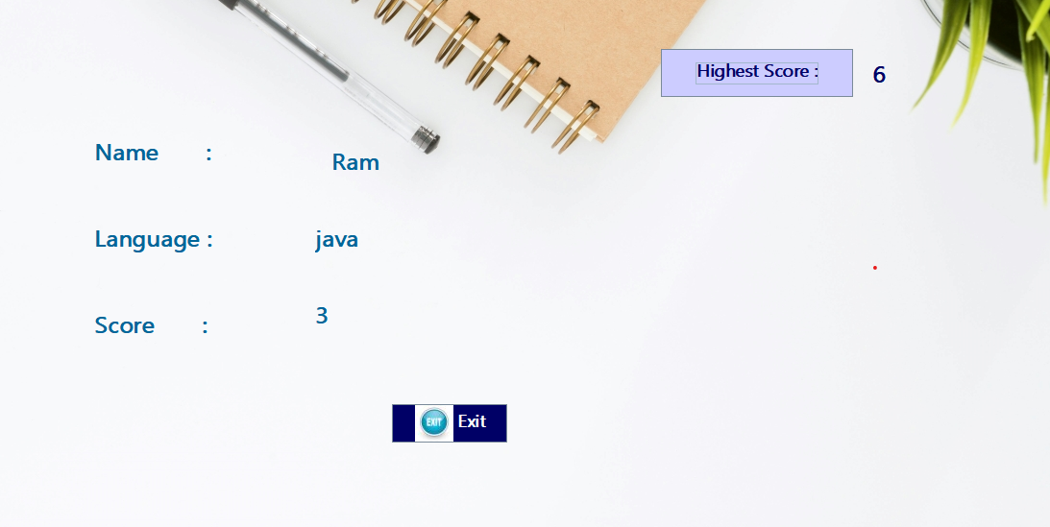

----- ADMIN SECTION --------

When you click on admin button from home page the update page will open .

ADD--At a Update page we can add the new question with its id ,four options and correct answer

but we have to choose one language [ C,CPP,JAVA ,HTML ,OOPS] after click on submit button.

[Note - please write id number 5 beacause 5 question in already inserted in each tables ]

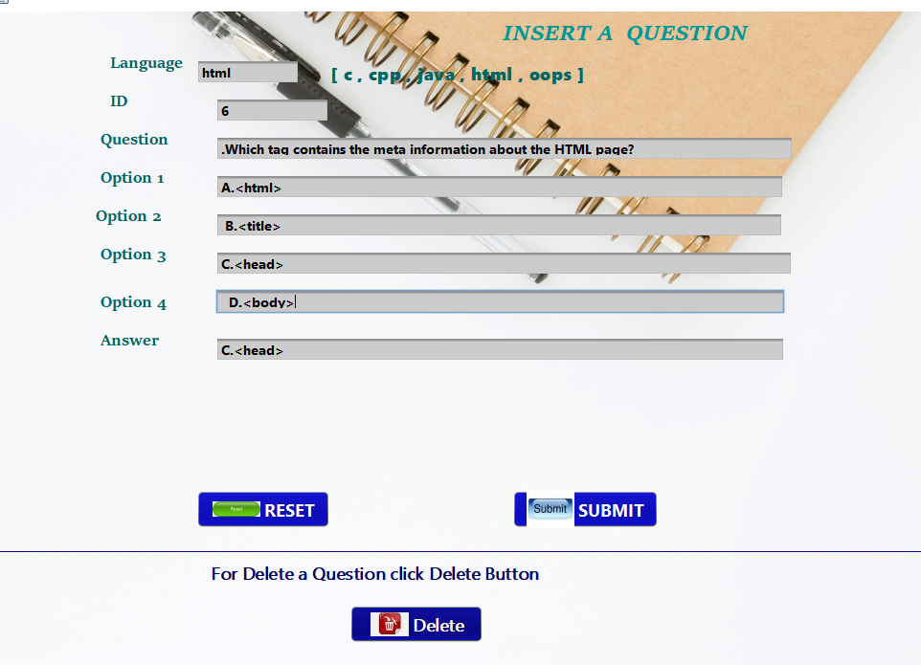

Delete- On upade page their is delete button at click delete page will open.

at delete page simpley write id number and language of programing quiz [ C, CPP,JAVA ,OOPS ,HTML].

If id number is available in that table it will deleted otherwise it will show failed deletion process .

